# Assignment:

Break Out Session 2.

# Group:

Group 1: Cason Konzer, Tom Green, Mike Turley.

# Instructions:

One use case diagram and one narrative use case (from one of the use case goals).

# Deliverable:

## Use Case Diagram:

### Actor: Cashier

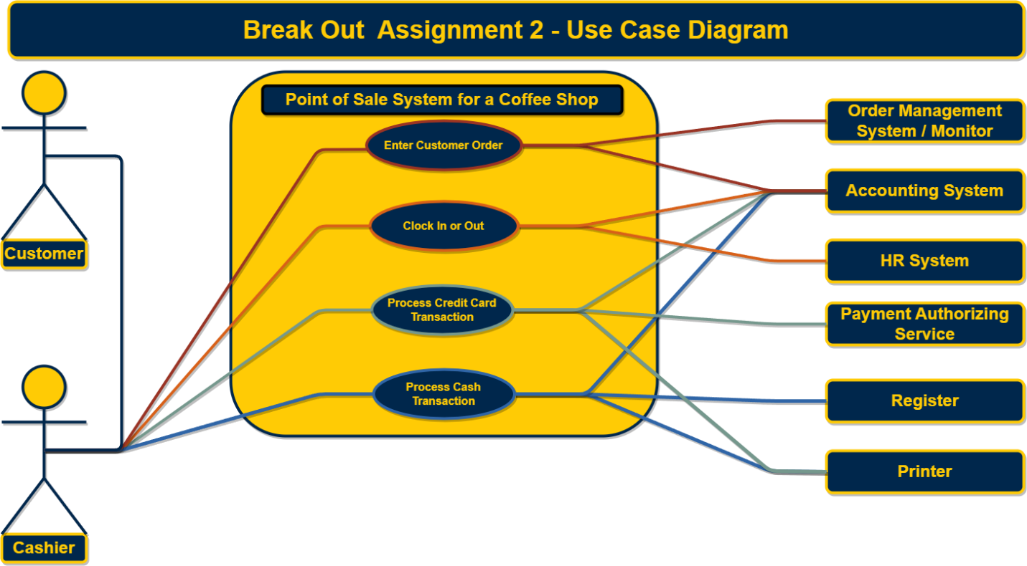

## Narrative:

### Actor: Cashier

### Action: Enter Customer Order

1. Precondition.
   1. The customer arrives at the register or drive through.
   2. The cashier greets the customer and requests order.
2. Trigger
   1. The customer provides details on the requested order.
3. The cashier enters order details into the point-of-sale system.
4. The point-of-sale system processed the order.
   1. The point-of sale system sends order details to the order management system / monitor.
   2. The point-of-sale system deducts the order inventory within the accounting system.
   3. The point-of-sale system displays to the cashier an `order was successfully placed` message.
5. Post-condition.
   1. The cashier informs the customer that their order was successfully placed.